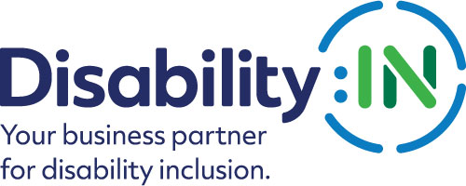
2024 Disability:IN Inclusion Awards
Affiliate of the Year
Award Nomination Form

THE DEADLINE FOR NOMINATIONS IS
FRIDAY, NOVEMBER 17, 2023

The Affiliate of the Year Award honors an outstanding Disability:IN Affiliate that has demonstrated exemplary efforts in promoting the vision, mission, and spirit of Disability:IN. As a result of this Affiliate’s efforts, employers and their communities understand, utilize, and benefit from the valuable resources that people with disabilities present in the workplace, supply chain and marketplace. Self-nominations are encouraged.

Please note that if your company is selected to receive this award, you will be required to attend the 2024 Disability:IN Global Conference and Expo in Las Vegas, July 15 – 18 to accept your award.
*If you have received this award within the past five years you are not eligible to apply. Your Affiliate must be three years old to receive this award.

Award Criteria:

- An Affiliate is a recognized Affiliate of Disability:IN who is in GOOD STANDING with Disability:IN. The requirements to be in GOOD STANDING include the following:
- Non-profit status required: Operating as either a 501(c)(3) or having a documented fiscal sponsor with a signed MOU in place.
- Completed and signed Affiliate Agreement. Submitted a 2022 Annual Report/supporting documents.

Please complete the nomination form in its entirety and include a roster of your voting Affiliate board members/steering committee with titles and companies represented.

- Organization Name:
- Contact information for the primary person to be notified:
Name
Title
Organization
Mailing Address
Phone
Cell
Email
Relationship to affiliate

- Contact information of a secondary person to contact:
Name
Title
Organization
Mailing Address
Phone
Cell
Email
Relationship to affiliate

- Contact information of the person completing the nomination form:
Name
Title
Organization
Mailing Address
Phone
Cell
Email
Relationship to affiliate

- Please provide an overview of the affiliate including founding date, mission statement, strategic goals for calendar year 2023, and number of partners. (500 words or less)

- Please describe the initiatives and programs the affiliate has implemented in calendar year 2023 to promote inclusive and equitable businesses for all. Please describe your affiliate’s measurement tools and/or provide as many metrics as possible to support your descriptions. Links to supporting information are encouraged. (2000 words or less) 60 points

- Please provide 2-3 examples of how your affiliate has helped businesses in your community to achieve disability inclusion and equality. Links to supporting information are encouraged. (1,000 words or less) 25 points

- Please describe how your affiliate has demonstrated exemplary efforts in promoting the vision, mission, and programs (i.e., Accessibility, Disability Equality Index, NextGen Leaders, Supplier Diversity) of Disability:IN. (500 words or less) 15 points

PLEASE DO NOT CONVERT FORM TO PDF. Submit your electronic nomination, your voting public board/steering committee member roster and any supporting documents to awards@disabilityin.org

Award recipients will be recognized and receive their awards during the 2024 Disability:IN Global Conference and Expo in Las Vegas, July 15 – 18. Please note that late nominations will not be accepted.

THE DEADLINE FOR NOMINATIONS IS
FRIDAY, NOVEMBER 17, 2023

