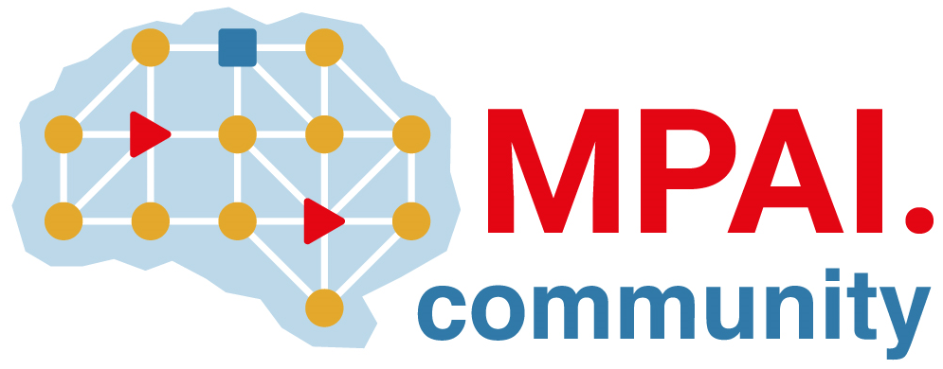 | Moving Picture, Audio and Data Coding by Artificial Intelligence  www.mpai.community

N24 | 2022/02/23
Source | Leonardo Chiariglione
Title | MPAI Membership Application Templates
Target | MPAI Directors

This document contains two templates:
- For corporate/university Membership applications
- For individuals applying for Membership in accordance with Article 4.2 of the Statutes
Please use one that applies to your case and delete the other.

For corporate/university Membership applications

I, the undersigned, in my capacity as [CEO/Dean etc.] of [Company/University name] requests to join Moving Pictures, Audio and Data Coding by Artificial Intelligence (MPAI) as a [Principal/ Associate] Member {delete the item that does not apply to you} according to Article 4.1 of the Statutes.
[Company/University] has the necessary internal expertise to make technical contributions to the development of MPAI Technical Specifications.
[Company/University] supports the MPAI mission as articulated in Article 3 of the MPAI Statutes.
I attach to this declaration the record of payment of the membership fees.
Best regards

For individuals applying for Membership in accordance with Article 4.2 of the Statutes

I, the undersigned, in my capacity as [Director, Vice Director, Professor etc.] of [Department name of University name] requests to join Moving Pictures, Audio and Data Coding by Artificial Intelligence – MPAI as an individual Member in accordance with Article 4.2 of the Statutes.
I support the MPAI mission as articulated in Article 3 of the MPAI Statutes.
I have the necessary internal expertise that allows the department I represent to make technical contributions to the development of MPAI Technical Specifications.

I attach to this declaration the record of payment of the membership fees.
Best regards

