INTERNATIONAL ORGANISATION FOR STANDARDISATION
ORGANISATION INTERNATIONALE DE NORMALISATION
ISO/IEC JTC 1/SC 29/WG 11
CODING OF MOVING PICTURES AND AUDIO

ISO/IEC JTC 1/SC 29/WG 11 N 17476
Gwangju, KR – January 2018

Source: | Leonardo Chiariglione
Title: | Notice of 122nd WG 11 meeting

Notice of 122nd WG 11 meeting

The 122nd MPEG Meeting will take place from 16 to 20 April 2018 at
San Diego Marriott La Jolla | P: +1-858-587-1414
4240 La Jolla Village Drive | F: 858-546-8518
San Diego, California, USA 92037
Please note the main meeting (2018/04/16-20) will be preceded by meetings of
- JVET (from Tuesday 10 April)
- JCT – VC (from Friday 13 April)
- MPEG Ad hoc Groups (Saturday and Sunday 14 – 15 April)

Meeting Venue

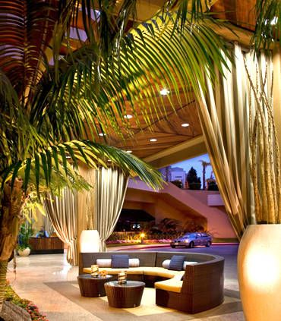

All meetings will be held at the San Diego Marriott La Jolla.

San Diego Marriott La Jolla

4240 La Jolla Village Drive

San Diego, California, USA 92037

P: +1-858-587-1414 | F: 858-546-8518

Meeting Web Site
Meeting information, registration, hotel information and local information can be found at the following web site.

http://2018isoiec.regstep.com/home/page/index

Meeting Host
INCITS L3 (InterNational Committee for Information Technology Standards. Coding of Audio, Picture, Multimedia and Hypermedia Information)

Meeting Organizer
Julie Higgins
Meeting Planit
jhiggins@meetingplanit.com
Phone & Fax: +1-612-922-5986

Destination Information
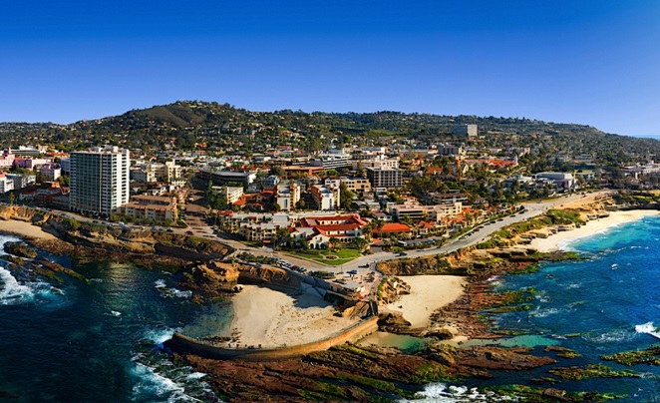

Located within the area's famous Golden Triangle, the hotel is conveniently located directly off major freeways (I-805 and I-5) 24 km north of San Diego International Airport (SAN) and

within easy reach of many of downtown La Jolla's most popular attractions, as well as the University of California at San Diego. For those who want to explore the area Scripps Institution of Oceanography, the La Jolla Cove, and the beach are within a few minutes of the hotel.

Social Event
All registered attendees are invited to the Wednesday evening social on 18 April from 18:30 to 22:00 at the Scripps Seaside Forum.

Travel Documents and Visas
If an invitation letter is required:
- Fill out the request form
- Please send completed form to ANSI to receive an official invitation letter. One form per delegate.

Registration and Information Desk

The registration and information desk hours are: Monday, 9 April to Saturday, 21 April 2018 from 08:00 to 18:00

Name Badges: You will receive your name badge upon check-in at the Registration and Information Desk. Your name badge is required for admittance into meeting rooms, breakfasts and breaks.

Facilities Fee

The facilities fee includes:
- meeting rooms with wireless Internet access, A/V equipment and power plugs
- daily continental breakfast and two coffee breaks
- a dedicated, staffed registration and information desk

Price changes occur at midnight (23:59) Pacific time on 8 March 2018. You must complete your registration before that time to receive the early bird rate.

$600.00 USD early birds, until 8 March 2018
$700.00 USD regular on or after 9 March 2018

Additional tickets for social will be made available for $50.

To register for the meeting, click here.

To reserve hotel rooms, click here.

Cancellation Policy

Cancellations before 13 March 2018: 100% refund

Cancellations on or after 13 March 2018 and before 10 April, 2018: 70% refund

Cancellations on or after 10 April: no refund

Hotel Guest Room Cancellation

Refunds will be made only on reservations cancelled more than 72 hours prior to arrival. There will be a one (1) night charge for any reservation cancelled within 72 hours of your arrival date.

Currency/Credit Cards
The facilities fee may be pre-paid by Visa, Mastercard, Discover, or American Express credit cards, or by company check or wire. Alternatively, you may pay with US dollars or travelers checks on site.

Accommodations
San Diego Marriott La Jolla
4240 La Jolla Village Drive
San Diego, California, USA 92037
P: +1-858-587-1414 | F: 858-546-8518

The hotel accepts Visa, Mastercard, American Express, Diners and Discover cards. A bank money dispensing machine is located in the hotel.
To make hotel reservations, click here.

The group rate is $179.00 per night, plus tax. The group rate will be available until March 23, 2018.

Hotel Guest Room Cancellation: Refunds will be made only on reservations cancelled more than 72 hours prior to arrival. There will be a one (1) night charge for any reservation cancelled within 72 hours of your arrival date.

Getting to the Hotel
The hotel does not provide complimentary transportation from the San Diego Airport. However, several shuttle companies are located right outside baggage claim – after claiming your luggage, walk outside toward hotel shuttle signs, then look for La Jolla hotels (only). Shuttles run every 18-25 minutes.

By Car from the San Diego International Airport
North on I-5. Exit La Jolla Village Drive and turn right toward East. Turn left on Regents Road and immediately turn right to Regent Park Row. Hotel driveway is on the right hand side.

On-site Parking without hotel stay
Self-parking: $4.00/hour, $30.00/daily
Valet Daily: $36.00

Discounted parking with hotel stay

Self-parking: $10.00 per night
Overnight valet: $35.00 per night

Hotel Amenities

Radio and Alarm clocks with MP3

High Speed wired and wireless internet

Remote guest room printing

Coffeemaker and complimentary coffee

Five in-hotel dining options with many restaurants within walking distance

Outdoor swimming pool, hot tub and fitness center

Local Area Information
San Diego is California's second largest city, with more than 70 miles of majestic coastline and a gentle Mediterranean climate. Bordered by the Pacific Ocean to the west, the Anza-Borrego Desert and the Laguna Mountains to the east, and Mexico to the south, the diverse neighborhoods of San Diego are spread out over 4,200 square miles, offering endless opportunities for exploration and activities.

La Jolla
The coastal village of La Jolla, appropriately meaning "The Jewel" in Spanish, is one of the most popular and picturesque destinations in the world. With a dramatic coastline ideal for swimming, surfing, diving, kayaking, and snorkeling, La Jolla's beaches are just one of the features that make this village a highly desirable destination for visitors. La Jolla offers world-class shopping and dining experiences, from designer boutiques and art galleries, to critically acclaimed restaurants featuring celebrity chefs. La Jolla's cultural offerings include the renowned Birch Aquarium at Scripps, the Museum of Contemporary Art, and La Jolla Playhouse. There are many restaurants within walking distance from the meeting venue.

Local Attractions

Seaworld

San Diego Zoo

La Jolla Shores and Cove

Birch Aquarium at Scripps

Legoland

Scripps Clinic - Torrey Pines

San Diego Mormon Temple

Seaport Village

Veterans Memorial Walls at Mt. Soledad

Balboa Park Visitors Center

More Activities
- Bike rentals 1.1 miles
- Biking trail 2 miles
- Bowling 4.4 miles
- Hiking 4 miles
- Horseback riding 4.7 miles
- Jet-skiing 8 miles
- Jogging/fitness trail 2 miles
- Kayaking 8 miles
- Miniature golf 4 miles
- Nature preserve, trail 4 miles
- Rock climbing 3 miles
- Sailing 10 miles
- Sauna 0.1 miles
- Squash 0.5 miles
- Surfing 5 miles
- Volleyball 2.8 miles
- Water-skiing 8 miles
- Snow skiing 90 miles
- Snow skiing 330 miles
- Tennis 0.1 miles

Time Zone
La Jolla (San Diego) is on Pacific Standard Time (PST) and 8 hours behind Greenwich Mean Time.

Climate
The average April temperature is 19.7°C high and 13.3°C low.

Electricity
The voltage in California is 110V. Two-pin plugs are standard.

