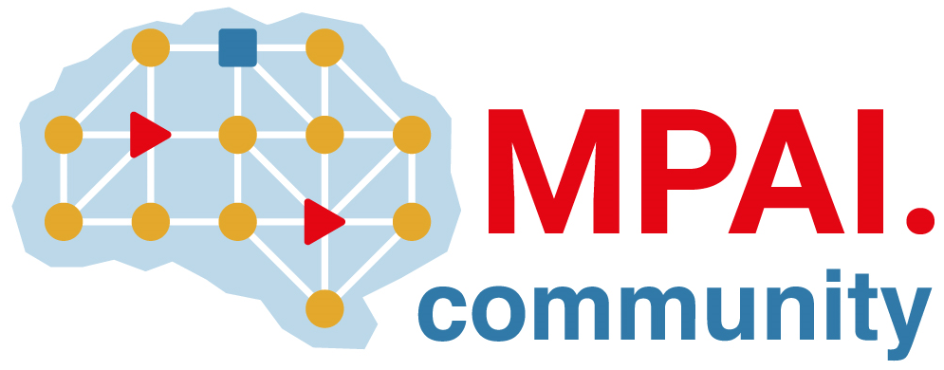 | Moving Picture, Audio and Data Coding by Artificial Intelligence  www.mpai.community

Public document
N1210 | 2023/05/17
Source | Requirements (AIH)
Title | MPAI-AIH Progress report and plans
Target | MPAI-32

The Use Cases and Functional Requirements document has been further developed.

