Boards Are IN
Modernizing the Corporate Board to Include People with Disabilities
An Initiative of Disability:IN

Boards Are IN: Integrating Disability into Board Disclosure Matrices in Proxy Statements & Proxy Voting Guidelines

Background on Board Diversity
Despite international efforts to diversify corporate governance in recent years, corporate boards often overlook disability. This is evident in the dearth of governance frameworks that include disability in the nomination of new directors and in proxy statements that include disability disclosures for current directors.
In a report entitled Global Boardroom Diversity: Legal Findings on Disability & Diversity, Disability:IN and TrustLaw (2023) found that few jurisdictions around the world mandate companies to reveal whether their boards include individuals with disabilities. Even where companies are required to disclose the overall diversity of their boards, they are seldom obligated make disclosures specific to disability.
A closer look at disability inclusive companies in the U.S. reveals that only 2.5% of companies mention people with disabilities in documents that govern the nomination of directors and 2.4% of companies disclose disability status in their proxy statements. In these cases, disability is mentioned alongside the other facets of diversity (gender, race, ethnicity, sexual orientation, nationality, and/or age) as an additive differentiator for strong corporate governance. This document contains model proxy statements for including disability in board diversity disclosure matrices.

Why Disability is Additive to Corporate Governance
There is a well-documented business case for disability inclusion, first articulated by Accenture (2018, 2023) in Getting to Equal: The Disability Inclusion Advantage. Harvard Business Review (2023) recently explored the reasons why disability is a source of competitive advantage that humanizes company culture. These advantages translate to corporate governance where disability status enhances business acuity because disabled people experience society’s core institutions differently and have the ability to contribute additive and alternative logic to business decisions. People with disabilities bring a unique set of life-learned skills and perspectives that help boards make better decisions, which in turn benefits companies and their shareholders.

Model Disability Disclosures in 2023 Proxy Statements
American Water Works (2023, p. vii) | Karuna Therapeutics (2023, p. 20)
Avient (2023, p. 13) | Nordson (2023, p. 11)
Baker Hughes (2023, p. 11) | Premier (2023, p. 8)
Etsy (2023, p. 18) | Repligen (2023, p. 3)
Exelon (2023, p. 20) | SEI Investments (2023, p. 21)
GlobalFoundries (2023) | Silicon Laboratories (2023, p. 11)
IDEX (2023, p. 7) | Spire (2023, p. 15)
Inari Medical (2023, p. 14) | SSR Mining (2023, p. 21)
JetBlue (2023, p. 19) | WestRock (2023, p. 9)

Sample Disclosure. Etsy Proxy Statement, 2023.
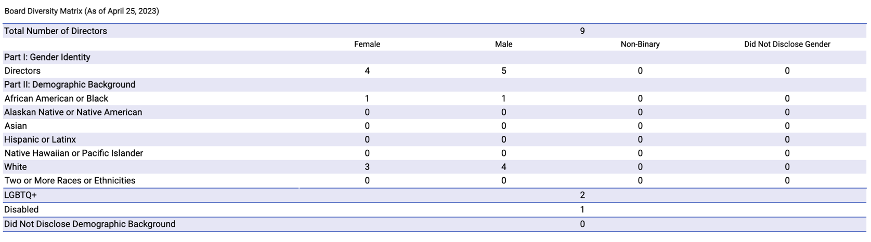
Sample Disclosure. JetBlue Proxy Statement, 2023.
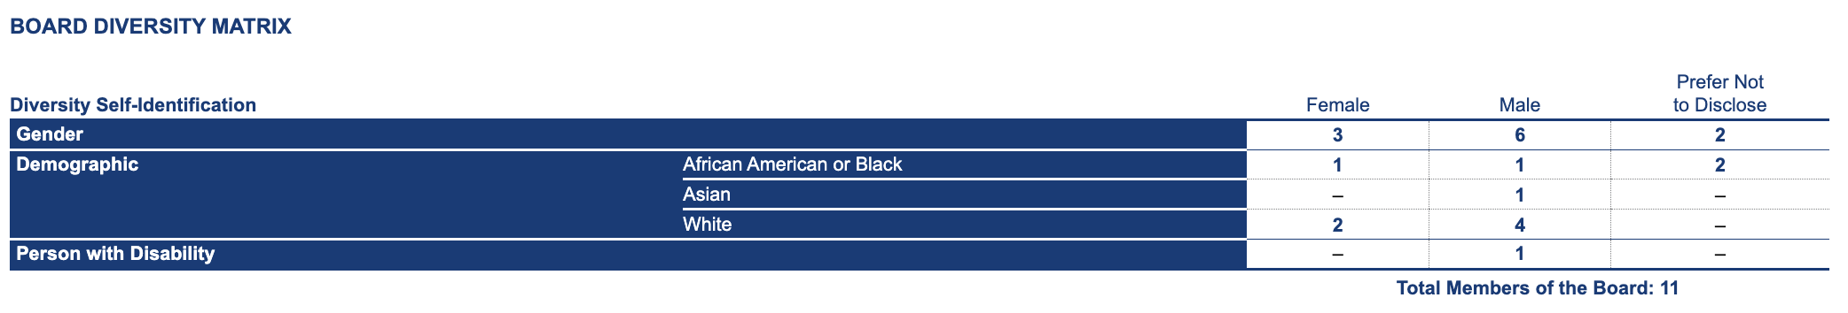

Sample Disclosure. American Water Proxy Statement, 2023.
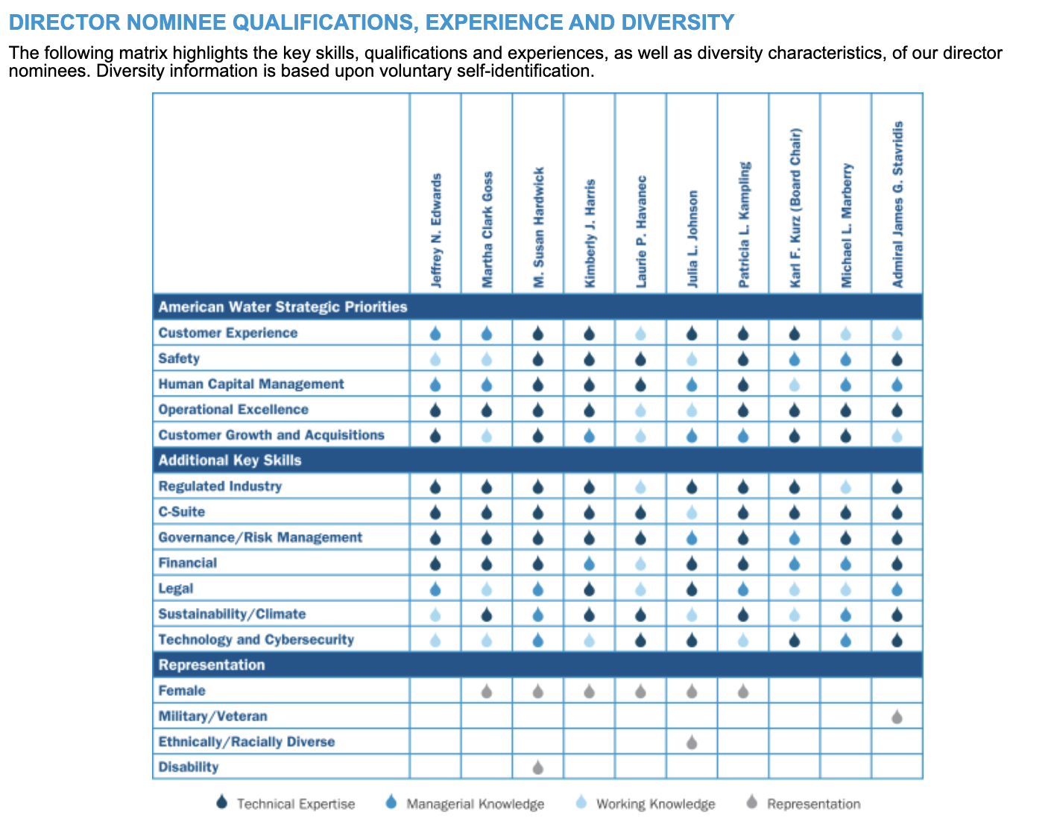

Model Proxy Voting Guidelines for Disability on Corporate Boards
New York State Common Retirement Fund Proxy Voting Guidelines (p.9)
“The Fund will scrutinize boards that are not sufficiently diverse, including diversity of age, race, gender, ethnicity, sexual orientation and gender identity, geography, and disability. A determination that a board is not sufficiently diverse may result in the Fund withholding support from incumbent board nominees.”

Support for Integrating Disability into Corporate Governance
“Including disability diversity in the corporate boardroom would mark a major turning point for disability rights and have the single largest impact on the economic independence and quality of life for millions of people with disabilities. If this omission persists, then Nasdaq and the SEC will miss an enormous opportunity to ensure that corporate leadership reflects the diversity of the U.S. and the world.” – Ted Kennedy Jr., Co-Chair of the Disability Equality Index, Past President of AAPD
“Boards are most effective at governing when members bring diverse abilities and perspectives to the table. While Nasdaq missed an opportunity to hold the torch, the disability community is now tuned in to the fact that they're being excluded. Through our engagement with corporate leadership and stakeholders, people with disabilities will have an opportunity to prove they belong at the highest levels of business.” – Jill Houghton, President & CEO of Disability:IN
“Companies should seize the opportunity to join the growing number of corporations that recognize the benefits of disability inclusion and are reporting their efforts.” – Thomas DiNapoli, New York State Comptroller

