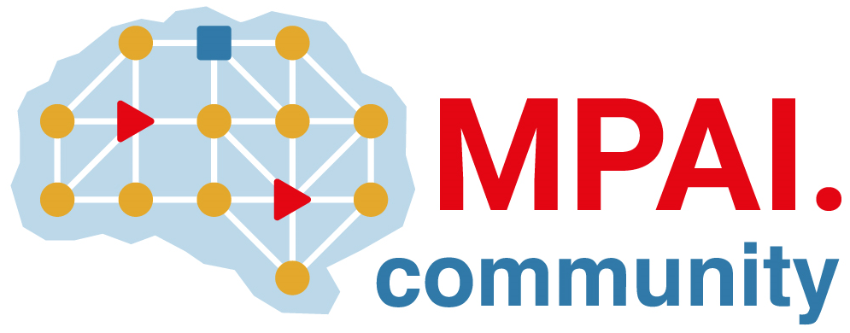 | Moving Picture, Audio and Data Coding  by Artificial Intelligence  www.mpai.community

 | Public document
N1212 | 2023/04/19
Source | Requirements (CAV)
Title | MPAI-CAV Progress report and plans
Target | MPAI-31

The paper “A metaverse model supporting connected autonomous vehicles” was submitted on the 8th of May 2023.
The last review of the UCFR document was initiated.

