**PNEUMOCOCCAL VACCINE SWITCH REQUEST FORM**

*Please email this form and every attachment requested to* [*proposals@gavi.org*](mailto:proposals@gavi.org) *with the Gavi Senior Country Manager for your country in copy.*

Please use this form to send Gavi the necessary information to review your country’s request to switch to a different Pneumococcal vaccine product or presentation[1].

0. Checklist

To process this request, Gavi requires your country to submit the following items/documents:

|  |  |  |  |  |  |
| --- | --- | --- | --- | --- | --- |
|  | **YES** | **N/A** |  | ***How to provide*** |  |
| * **Ministry of Health Signature** |  |  |  | *Form* |  |
| * **ICC endorsement** (minutes of a meeting endorsing the switch decision) |  |  |  | *Attachment* |  |
| * If available, **NITAG recommendation** |  |  |  | *Attachment* |  |
| * If this switch will increase financial costs to the country (e.g.co-financing amounts)[2], **Ministry of Finance Signature** |  |  |  | *Form* |  |
| * If a switch grant (SG) is requested, **Detailed Budget[3]** |  |  |  | *Attachment* |  |

**Requests will not be reviewed until complete**. Please use the checklist above to verify items/documents before submitting country request.

**1. Country Background**

|  |  |  |  |  |  |  |  |
| --- | --- | --- | --- | --- | --- | --- | --- |
| Date of the form | **DD/MM/YY** |  | Routine vaccination already started? | Yes  No |  | Did the country experience stock-out? | Yes  No |
| Country | **……………** |  | If Yes  Please indicate the stock level of current presentation (number of doses) | Central Level……………#  Second Level……………# |  | If Yes  Please estimate how many children missed vaccination due to stockout | ……………………………….....# |

2. SWITCH CHOICE[4]

|  |  |  |  |  |  |
| --- | --- | --- | --- | --- | --- |
| **Product** | Pneumosil[5] | Pneumosil[6] | Prevenar 13 | Prevenar 13 | Synflorix |
| **Presentation** | PVC10, 1 dose/vial | PCV10, 5 doses/vial | PCV13, 1 dose/vial | PCV13, 4 doses/vial | PCV10, 4 doses/vial |
| **Form** | Liquid | Liquid | Liquid | Liquid | Liquid |
| **Doses in each unit** | 1 | 5 | 1 | 4 | 4 |
| **Picture** |  |  |  |  |  |
| **Please rank in order of preference**  **(1= First Choice)** | **…** | **…** | **…** | **…** | **…** |

|  |  |  |  |  |
| --- | --- | --- | --- | --- |
| **3. Reason for Switching (PLEASE CHOOSE ONLY ONE)** | | **4. Reason(s) for Choosing Specific Product or Presentation** | | |
|  | | **Main Reason(s)** | | **Description** |
| 1. Supply of the current vaccine is disrupted |  | **Cost Driving Considerations** (e.g. wastage rate, price, price commitments) |  | ………………. |
| **2. Country’s own voluntary choice** |  | **Vaccine’s clinical profile** (e.g. country specific data, safety profile) |  | ………………. |
| 2.1 Availability of preferred vaccine (the country has been unable to use its preferred vaccine or presentation before due to a supply constraint) |  | **Logistic considerations** (e.g. VVM type, size of cartoons) |  | ………………. |
| 2.2 A new Gavi-supported vaccine or presentation or use is available |  | **Vaccine programmatic suitability** (e.g. dose schedule, ease of administration) |  | ………………. |
| 2.3 Country needs have changed (e.g. new epidemiology data, increased price sensitivity) |  | **Strategic/epidemiological reasons** |  | ……………….. |
| 2.4 Current vaccines profiles have changed (e.g. a price reduction, a VVM type change) |  | **Other reason(s)** |  | (Please specify) ………………. |

|  |  |  |  |  |  |  |
| --- | --- | --- | --- | --- | --- | --- |
| 5. Presentation |  |  |  | 6. Financial and Programmatic Considerations |  |  |
| Is the new presentation licensed in the country? | Yes | No |  | Will this switch increase the country’s financial costs (for example the co-financing amount)?  *If yes, please add the Ministry of Finance signature to this form* | Yes | No |
|  | | |  | Is there enough cold chain capacity at all levels to accommodate the vaccine in the current and future years? | Yes | No |
| If the preferred presentation does not yet have a license or approval, please provide the time to obtain a license or approval and specify whether national regulations allow for waiver or expedited registration procedure of a WHO Prequalified Vaccine. Please confirm if the licensing process will be completed before shipment. | | |  | Delivery date requested for the new vaccine product or presentation (actual shipment will depend on vaccine availability) | DD/MM/YYYY | |
|  | | |  | Planned Switch Date | DD/MM/YYYY | |
|  | Number of surviving infants who will receive the first recommended dose of vaccine in the first year of the planned switch date (please adjust depending on month) | ……………….# | |
| 7. Vaccine procurement | | |  | 8. Use of Financial Support to Fund Additional Technical Assistance Needs |  | |
| Gavi expects most countries to procure immunization supplies through UNICEF or the PAHO Revolving Fund.  Does the country need an alternative means of supply and delivery of immunization supplies (funded by the country or by Gavi)? | | |  | Through the participation of Gavi / TCA partners, Gavi funds tailored and differentiated technical assistance in response to specific country needs. Please review the currently approved Technical Assistance Plan (also known as the "Single Technical Assistance Plan") to assess whether the support required to implement a new vaccine is included in the approved technical assistance plan. If gaps in technical assistance are detected for support to new vaccines, the additional technical assistance required may be funded by the Product Switch Grant. In this case, the relevant costs must be indicated in the budgeting and planning model. | | |
| Yes  No  If you answered Yes, please attach a description of the mechanism and the vaccines or goods that the country intends to procure through this mechanism | | |  |

9. Switch Grant (SG)

Countries may apply for an additional switch grant to facilitate this transition. This grant intends to cover a portion of the one-time investments associated with the product, presentation, or use switch (e.g. training, document production and printing, procurement of cold boxes). The ceiling for the grant is US$ 0.25 per child for infant vaccines.

If you don’t request a switch grant, please leave the table below as is.

|  |  |  |  |
| --- | --- | --- | --- |
| (a) Gavi contribution per person in the target population (surviving infants) | 0.25 $ US | Funds needed in country by (planned disbursement date) | **DD/MM/AAAA** |
| (b) Surviving infants in the year of deployment (total number in that year) | **…………..#** | Please attach the [Gavi Budgeting and Planning Template](https://www.gavi.org/library/gavi-documents/guidelines-and-forms/budgeting-and-planning-template---user-guide/) to show how the Switch Grant will be used to facilitate the rapid and effective implementation of critical activities before and during the immunization. | |
| Total Gavi contribution | **………** $ US (a x b) |

10. Signature(s) from Government and coordination and advisory committees

The Government of COUNTRY would like to continue the existing partnership with Gavi for the improvement of the immunisation programme of the country, and specifically hereby requests Gavi support to switch pneumococcal vaccine product/presentation.

The co-financing commitments in this request include the amount of support in supplies requested from Gavi, and the financial commitment of the Government for the procurement of the above-mentioned vaccine(s).

Please note that Gavi will not review this request without the signature of the Minister of Health or their delegated authority.

*We, the undersigned, affirm that the objectives and activities in this request are fully aligned with the national health and immunisation strategic plans (or equivalent), and that funds for implementing all activities, including domestic funds and any needed vaccine co-financing will be included in the annual budget of the Ministry of Health.*

*We, the undersigned, further affirm that the terms and conditions of the Partnership Framework Agreement between Gavi and the Country remain in full effect and shall apply to any and all Gavi support made pursuant to this* request.

|  |  |  |  |
| --- | --- | --- | --- |
| Minister of Health**[7]**  (or delegated authority) | **Minister of Finance[8]  (or delegated authority)** | Required attachment:   1. **Minutes of the ICC meeting** where this request was discussed and approved, with signatures.   Optional attachment:  2. Minutes of the NITAG meeting where this switch was recommended |  |
| Name | Name |  |
| Date | Date |  |
| Signature | Signature |  |

Annex 1 – PNEUMOCOCCAL SWITCH REQUEST FORM – Example

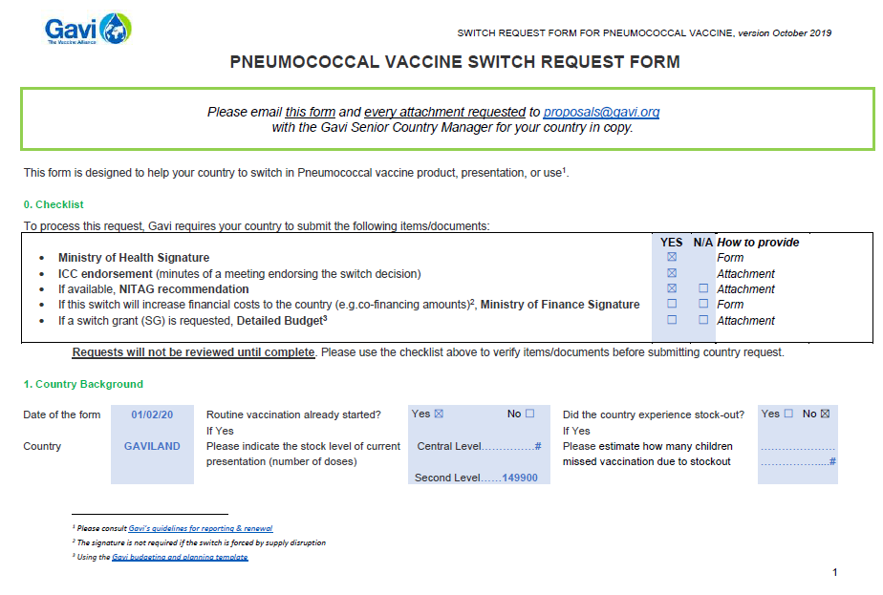 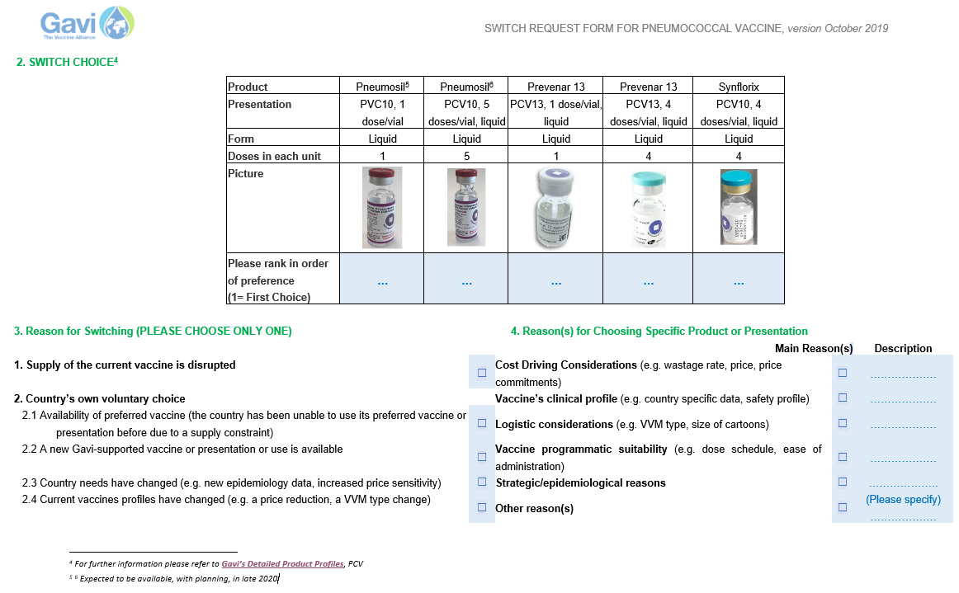

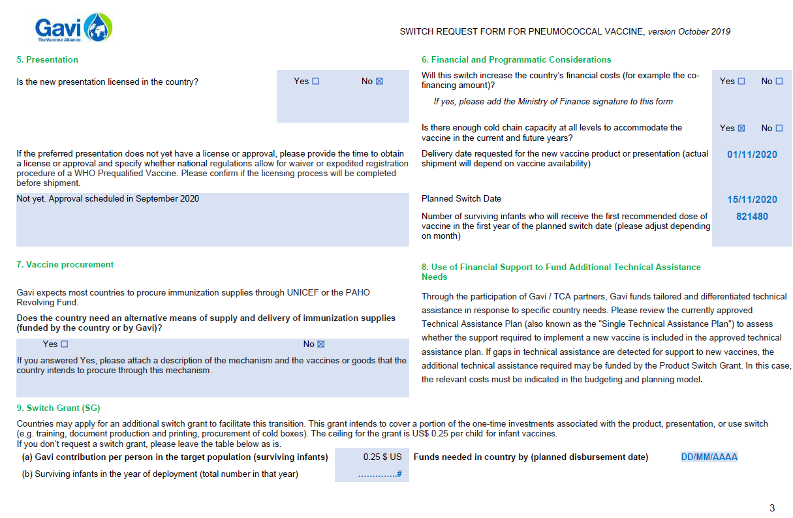 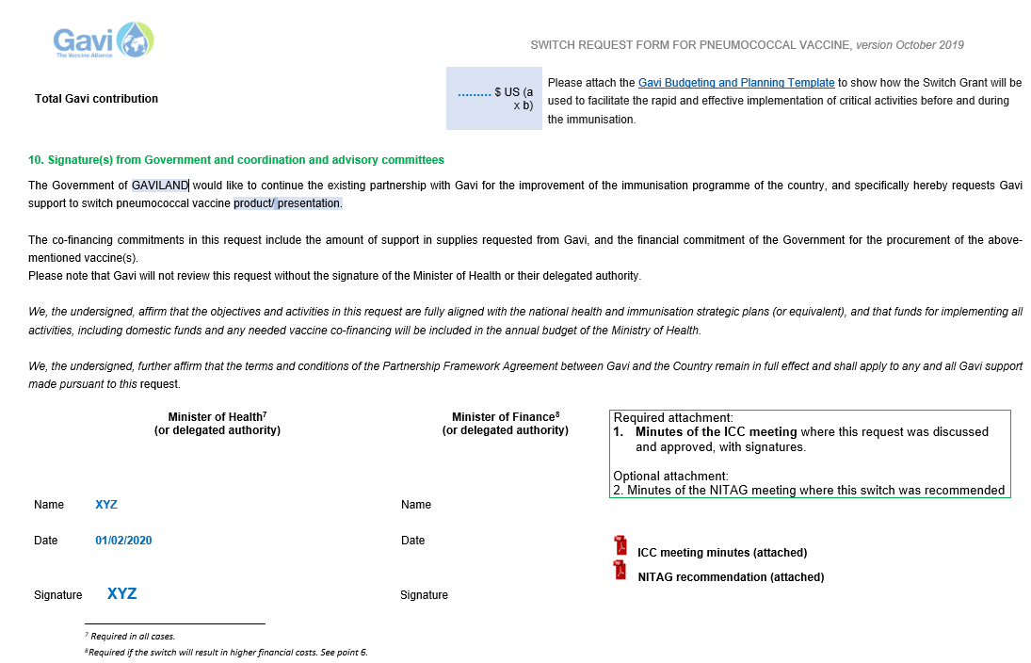

1. Please consult [Gavi’s guidelines for reporting & renewal](https://www.gavi.org/support/process/apply/report-renew/)
2. The signature is not required if the switch is forced by supply disruption
3. Using the [Gavi budgeting and planning template](https://www.gavi.org/library/gavi-documents/guidelines-and-forms/budgeting-and-planning-template---user-guide/)
4. For further information please refer to [**Gavi’s Detailed Product Profiles**](https://www.gavi.org/about/market-shaping/detailed-product-profiles/), PCV
5. 6 Expected to be available, with planning, in late 2020
6.
7. Required in all cases.
8. Required if the switch will result in higher financial costs. See point 6.